Part 1.

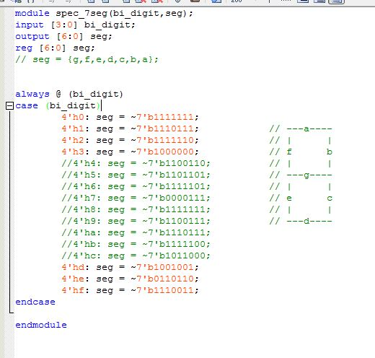

Part 2

4to1MUX

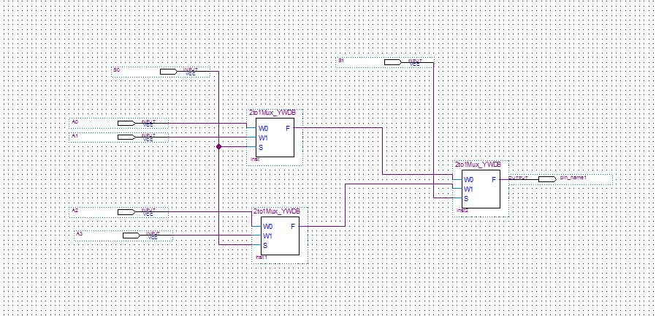

(b) 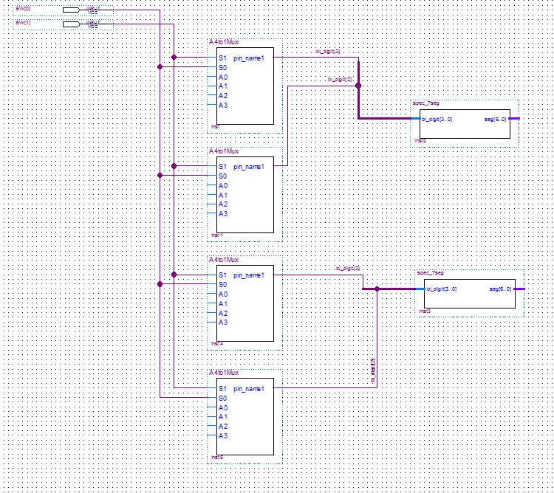

c) 00 is test, 01 is slow, 10 is medium, 11 is fast

d) The least significant bit is always 00 and only need to generate the other 2 bits.